SENIOR MANDATORY PARCHMENT UPDATE
Parchment stores a transcript in their system and sends that transcript each time you request one. The transcript currently stored there does not have second semester grades and does not reflect that you’ve graduated. You must update what is being stored so the correct transcript is sent.

Most students need to send a final transcript for the following reason:
- College Financial Aid – Colleges will put your financial aid on hold until they receive a final transcript showing that you’ve graduated.
- NCAA- A final transcript is required to confirm NCAA eligibility.
- Education Verification – Many employers request a final transcript showing graduation status.

Please follow these steps to update the transcript stored in Parchment.
- Log into Parchment.com account
- On home screen click on the picture of a transcript
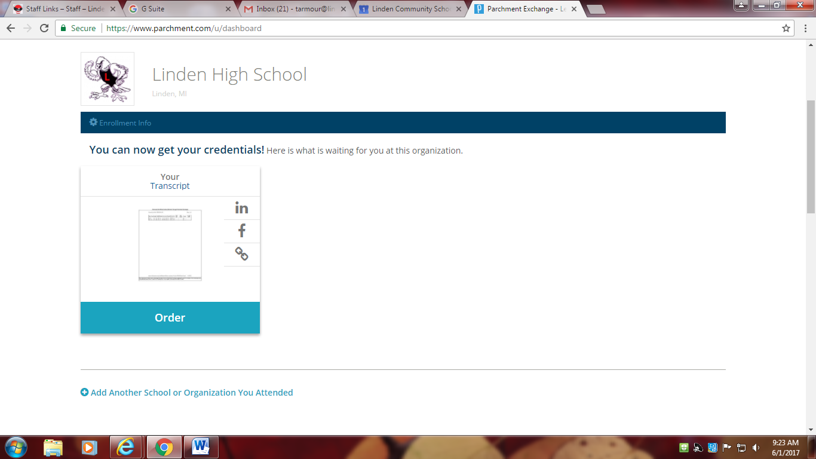

- Your transcript should load and be viewable
- At the bottom of your transcript is a link that says Update
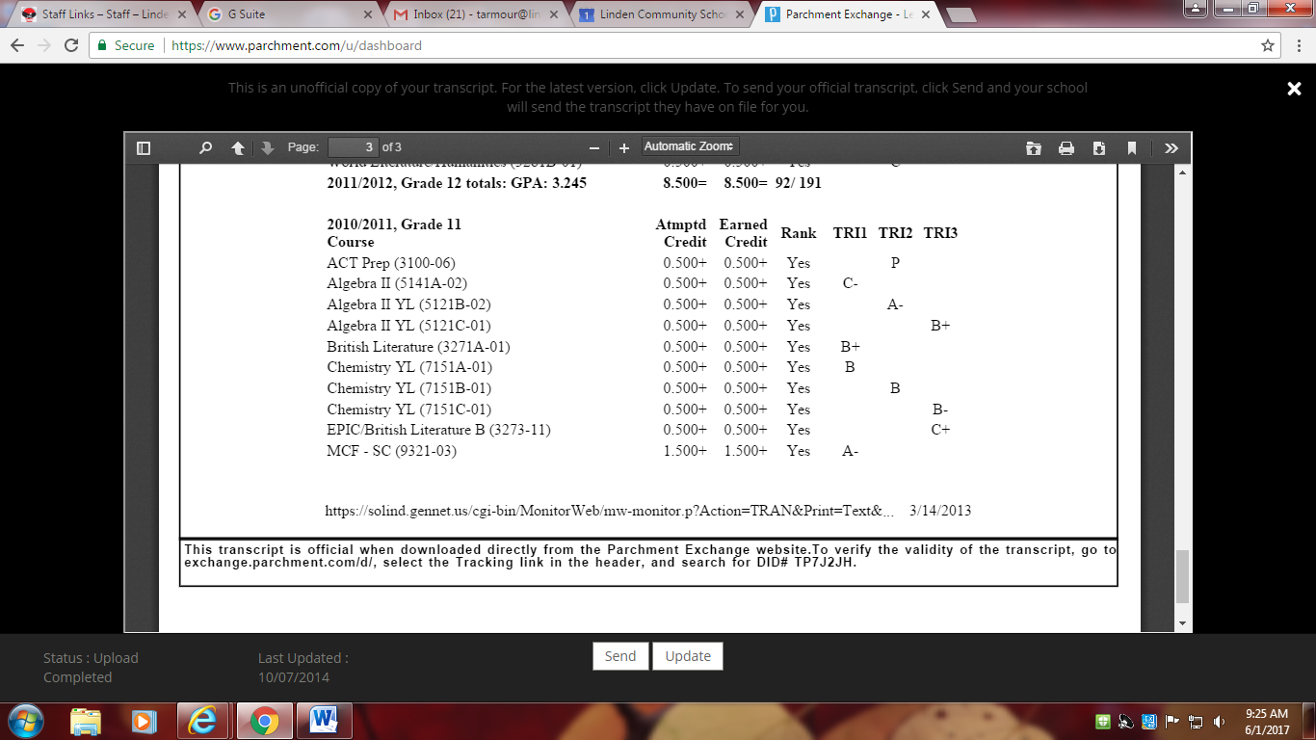

- Select Update
- The screen will now show only the Send option
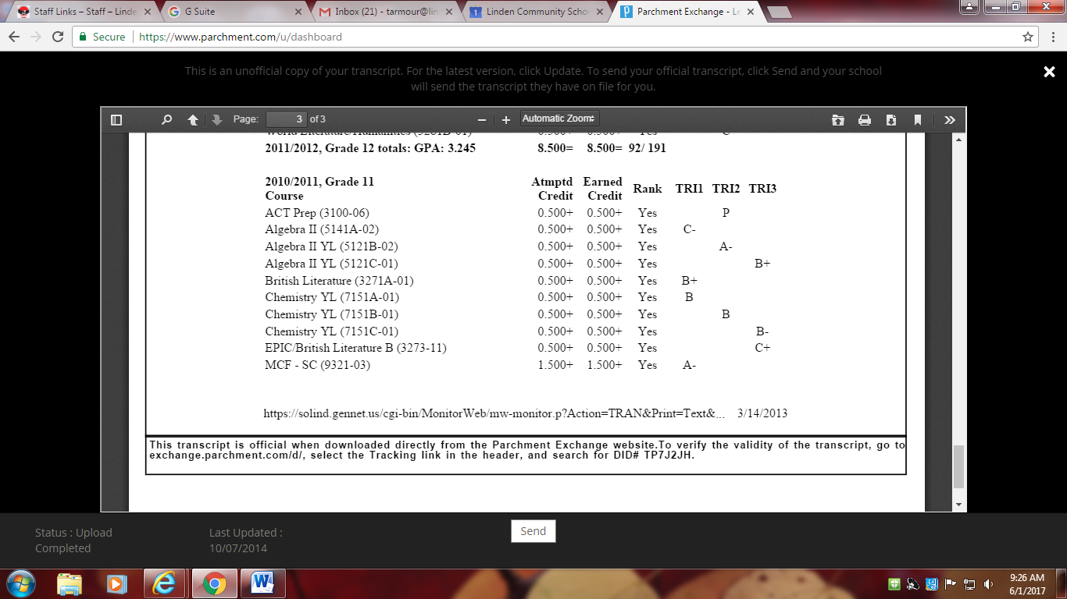

- Select Send
- Follow the steps to request that your transcript is sent to the college you’re attending in the fall, to NCAA, or to yourself.
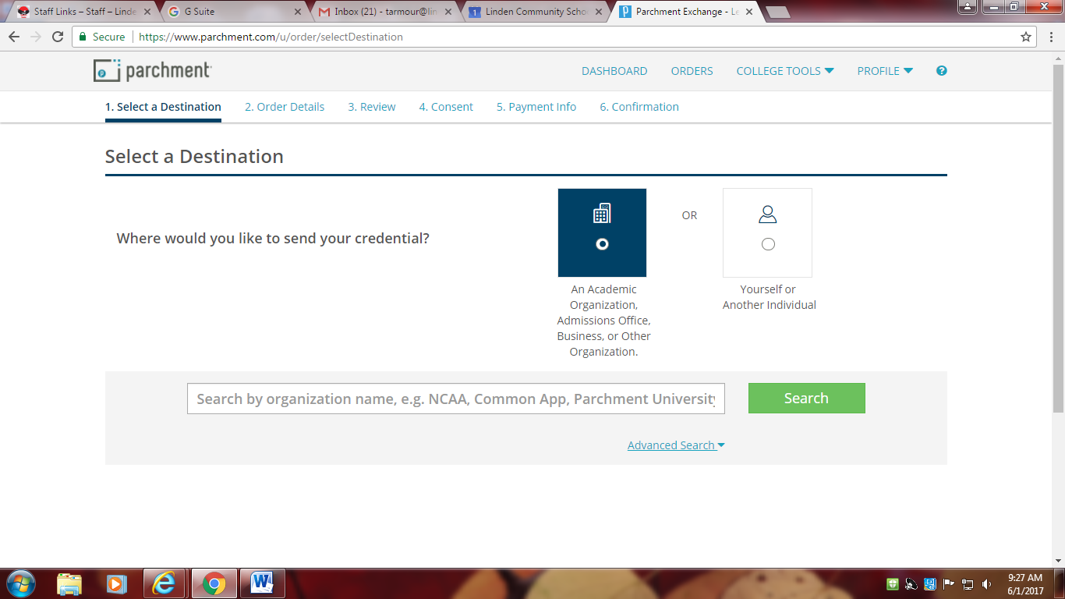
- Log back in on June 15th
- Open the stored transcript
- Make sure it shows a graduation date and second semester grades
- If it does not, please contact Cindy Day prior to June 21, 2017, at 810-591-0418, cday@lindenschools.org

In most instances, you can update and send your transcript for free up until July. At some point in July, Parchment will start charging you to update and send your transcript. Once you’ve updated and have confirmed that second semester graded and graduation status are accurate, you won’t have to update again.

If you’ve used your school email account to set up your Parchment account, change it NOW. Your school email account is being disabled June 30, 2017.

