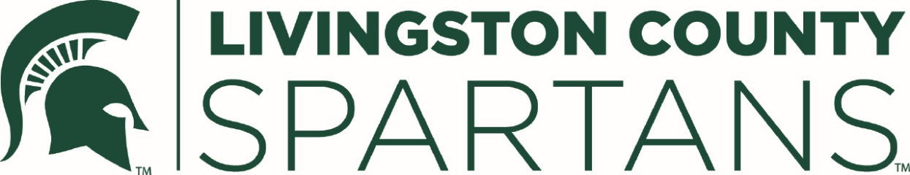

Dear High School Counselors:
The Michigan State University Alumni Club of Livingston County (Livingston County Spartans) is pleased to announce it will award $1000 Textbook Scholarships to graduates who reside in Livingston County and who plan to enter Michigan State University as Freshmen for the 2019-2020 academic year.

The Scholarship Application and instructions are available online at:

www.scholarships@livingstoncountyspartans.org

Applications must be fully completed and submitted online together with a Certified Transcript and the official Michigan State University Letter of Acceptance no later than Monday, March 4, 2019, and emailed to:

Janine Novak
scholarships@livingstoncountyspartans.org

Further, please emphasize that an Application for Scholarship is ineligible if not fully completed and timely filed as described in this letter and the Application.
If you or any of your students have any questions, do not hesitate to contact Janine Novak, Scholarship Committee Chairperson, scholarships@livingstoncountyspartans.org
Sincerely Yours,

Janine Novak
MSU Alumni Club of Livingston County
Scholarship Chairperson

Read carefully the Textbook Scholarship Requirements on Page 2

Page 2
LIVINGSTON COUNTY SPARTANS
2019 TEXTBOOK SCHOLARSHIP

Recognizing the increasing high costs of attending college, the Livingston County Spartans offer an annual Textbook Scholarship of $1000 to high school seniors residing in Livingston County. The funds are to be used for the purchase of textbooks, reading material, course packets, pamphlets, or other resource material required for the student’s courses while attending Michigan State University. The scholarships will be presented at the Club’s Freshmen Scholarship Picnic in August.
Scholarship Selection Criteria:
Applicants must meet the following criteria to apply for the scholarship:
- Is a high school senior residing in Livingston County
- Has been accepted at MSU for the Fall of 2019 and will enroll at MSU with at least 12 credits each semester
- May consider economic need

Requirements:
- Completed online application will be emailed to Janine Novak by due date, at: scholarship@livingstoncountyspartans.org by Monday, March 4, 2018.
- Two reference forms (should be completed by school administrator, counselor, teacher, coach, employer, religious leader, volunteer supervisor, or other professional that is aware of student’s accomplishments).
- At least one reference will not be connected to the applicant’s school.
- Copy of your MSU acceptance letterCopy of academic transcript from the high school (with parental consent).
Application Submittal:

Applications are available online at www.scholarships@livingstoncountyspartans.org or through your high school guidance counselor. Applications must be emailed by Monday, March 4, 2019. All applicants will receive an e-mail confirmation that their application has been received and will be notified of selected awardees.

The online application is an editable excel document that can be saved to the students’ computer, completed and then emailed.

