FLINT BRANCH
OF THE
NAACP
Serving Genesee County
Frances Gilcreast, President

ELEVENTH ANNUAL SCHOLARSHIP
Application online
http://www.naacpflint.org
Application deadline
January 26, 2019

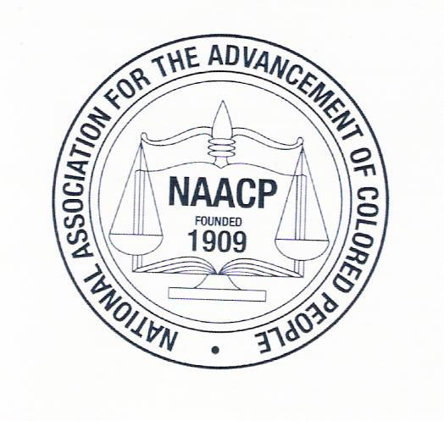
Mail To:
The NAACP
Scholarship Committee
3455 Lippincott Blvd.
Flint, MI 48507

